Alexander Baldree
05/06/26
Module 9.2 Assignment
CSD420

Java and Javac Version:
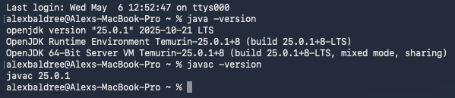
NetBeans installed and configured as ANT
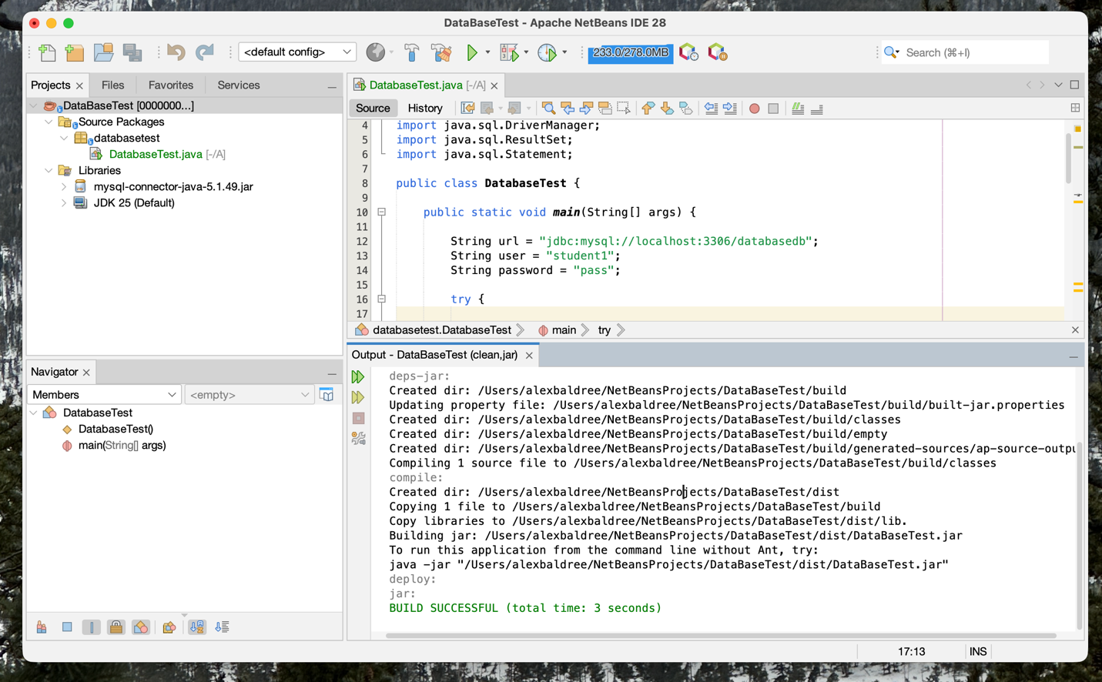

mySQL version installed
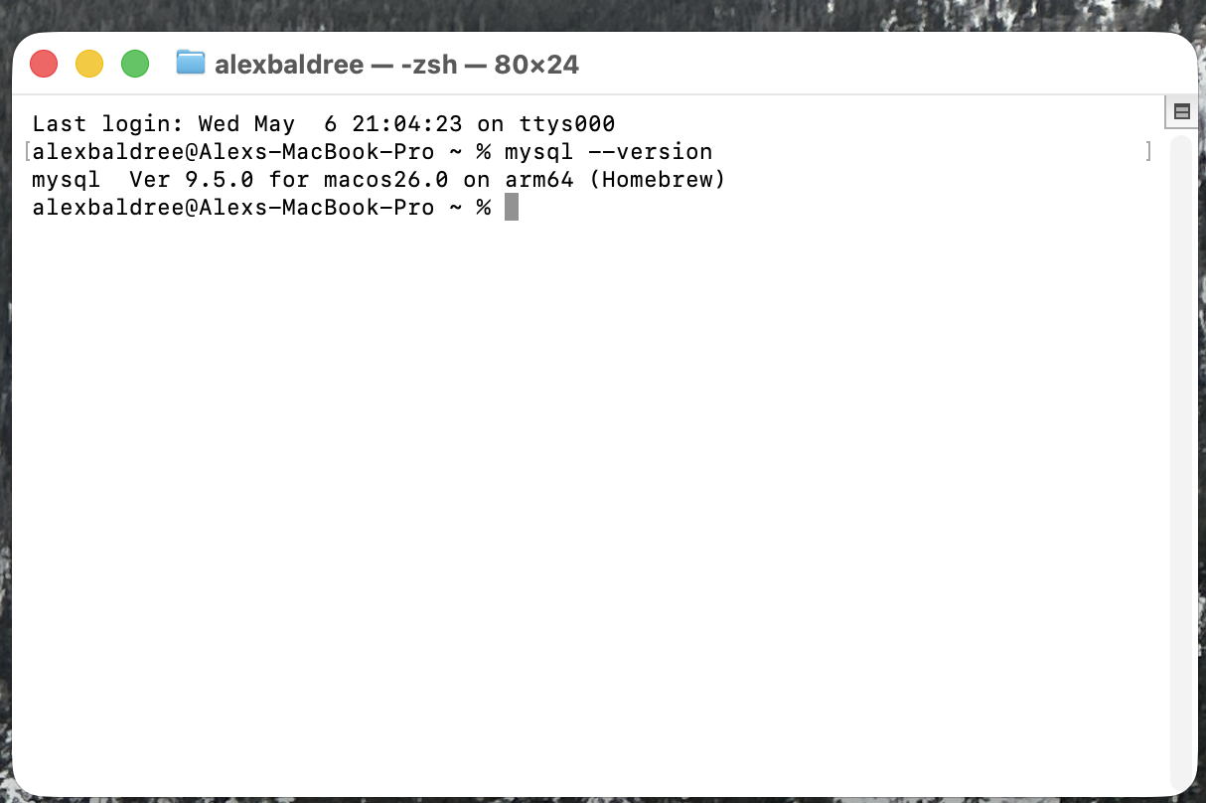
mySQL Login
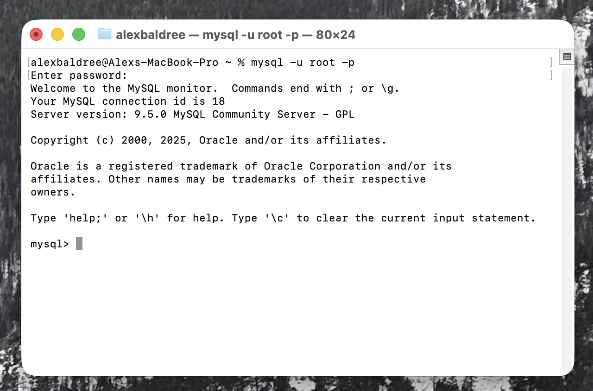
Create Tables address33
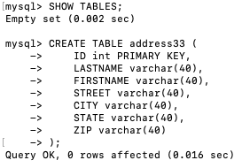

Studen1 Exists
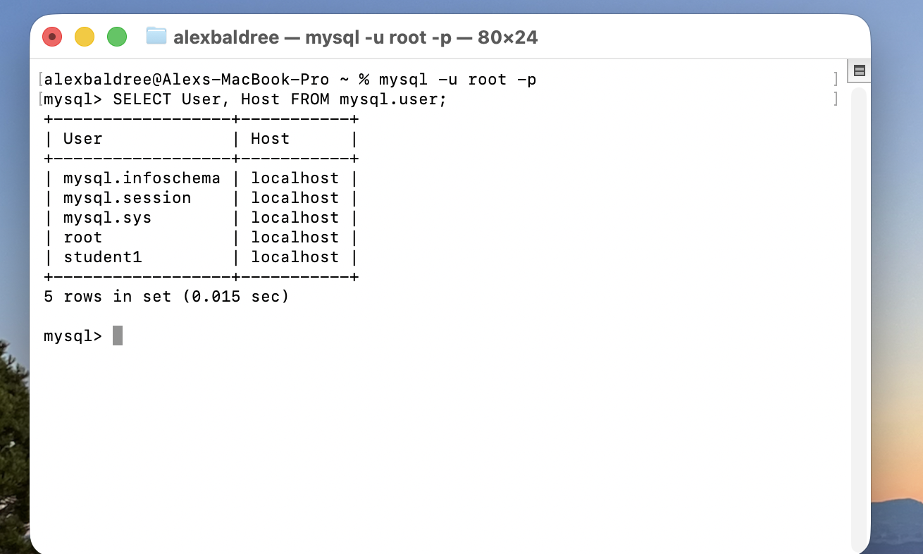
Databaseb exists
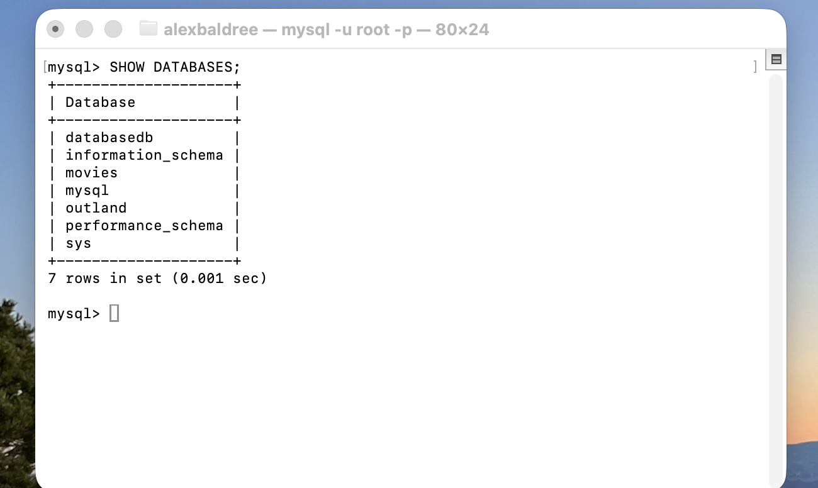

Table Exists
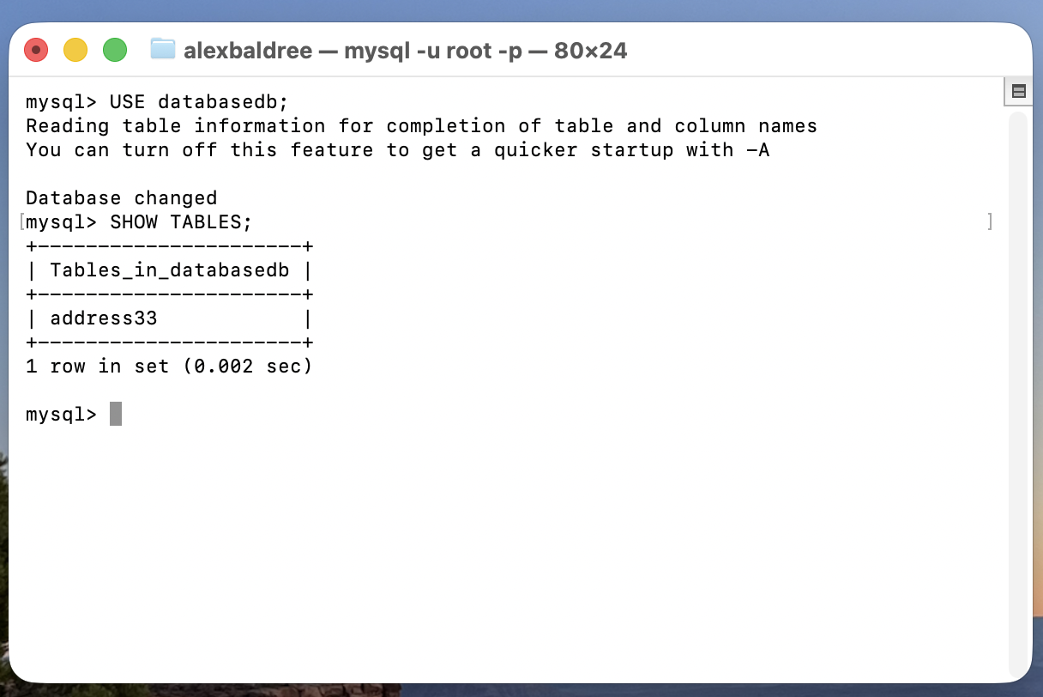
Table Data Inserted
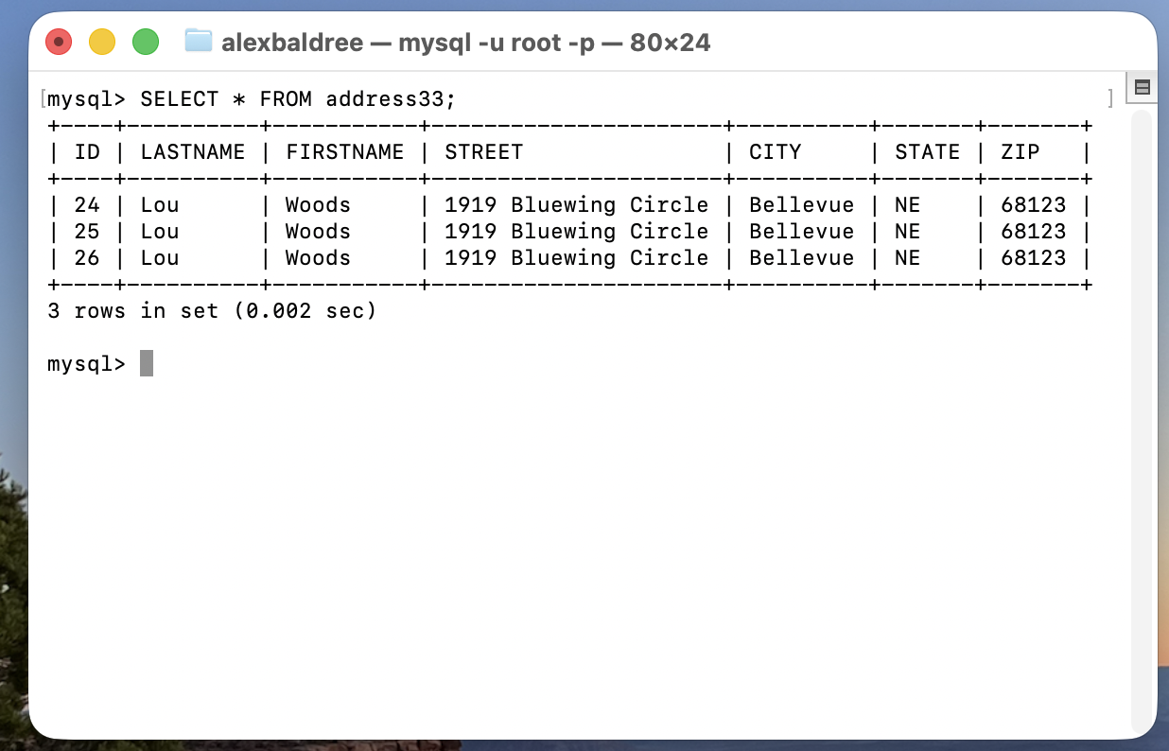
NetBeans MySQL connector added
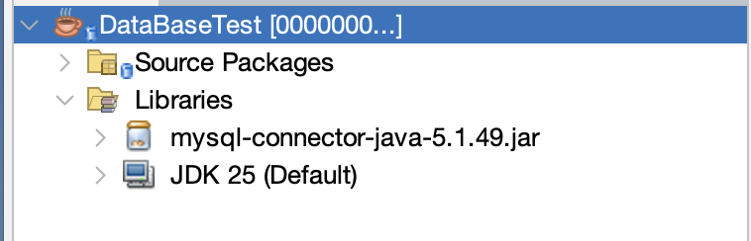
Java test App Run Successfully
